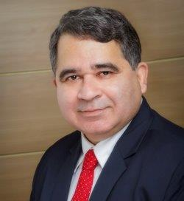

Mr. Arun Kapoor

Arun Kapoor, Chief Executive Officer, joined Dishtv on November 23, 2015.

Arun has a vast experience of over 32 years’, of which 16 years have been in senior management positions. He has worked with major global and Indian brands like Gillette, Pepsi, Luxor, Airtel and Hutch. Arun is a seasoned Media industry executive having led Zee Turner, Big TV DTH, Media Pro and Taj TV for around 9 years. Mr. Kapoor holds a Master’s degree in Business Administration from Jamnalal Bajaj Institute of Management Studies, Mumbai. Prior to joining Dishtv, he was CEO of Taj Television handling the subscription revenues of Zee and Turner Channels.

Arun is a seasoned Media industry executive having led Zee Turner, Big TV DTH, Media Pro and Taj TV for around 9 years. He has successfully managed complex JVs between Indian Promoters and Foreign Companies, involving high degree of Shareholder collaboration, alignment and management. He has been actively involved in Industry, Government and Regulator level discussions and policy making.

