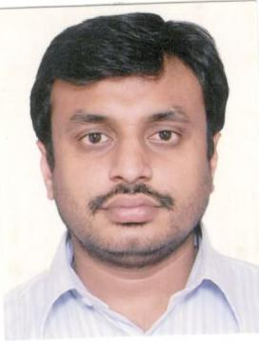

Mr. Gaurav Goel

Gaurav Goel, President – Business Development and Strategy joined Dishtv on October 1, 2011. In his role as President – Business Development & Strategy, Mr. Gaurav Goel is responsible for the finalizing the business Strategy for the development & growth of the Dish TV product.

Mr. Goel holds a Bachelor of Science and business administration, with specialization in finance and marketing, from the University of Denver, United States of America and has rich experience in the media industry. Mr. Gaurav Goel has undertaken various successful initiatives during his stay with the Company. Starting with taking care of the overall operations of the Company for the state of Delhi to handling the customer retention, enriched services and overall raising the bar of performance across all parameters. Gaurav has contributed towards the growth and performance of the Company and has been instrumental in finalizing the Business strategies which has given the required traction to the Company.

