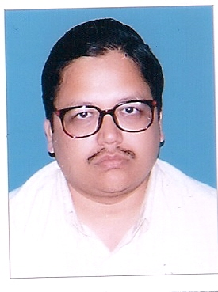

Mr. Rajeev K. Dalmia

Rajeev K. Dalmia, Chief Financial Officer, joined Dishtv on January 5, 2007. He is responsible for managing the financial risks of the Company, financial planning and maintaining Financial Records of the Company.

He is a qualified fellow chartered accountant from the Institute of Chartered Accountants of India and a commerce graduate from St. Xavier’s College, Calcutta. Rajeev has a vast experience of over 28 years in diverse organisations including Petrochemicals, capital markets and Textile industries. Prior to joining Dishtv, he was senior vice-president - finance of South Asian Petrochem Limited from September 2000 to December 2006.

