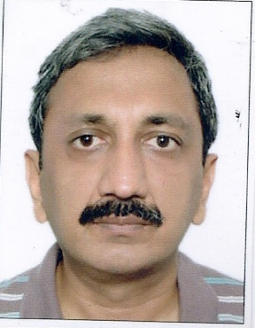

Mr. Veerender Kumar Gupta

Veerender Kumar Gupta, Chief Operating Officer, joined the organization in April 2009. He is responsible for information technology, business process excellence and Usage & Retention for our Company.

He has more than 21 years of work experience. As chief operating officer, he is responsible for strategizing, improvising and establishing both front-end services and back-end center for addressing the needs of our subscribers, ensuring utmost customer satisfaction and build on the brand value. He is responsible for technology requirements for front-end service and call center operations. He holds a bachelor degree in commerce from Delhi University and a diploma in systems management from National Institute of Information Technology

